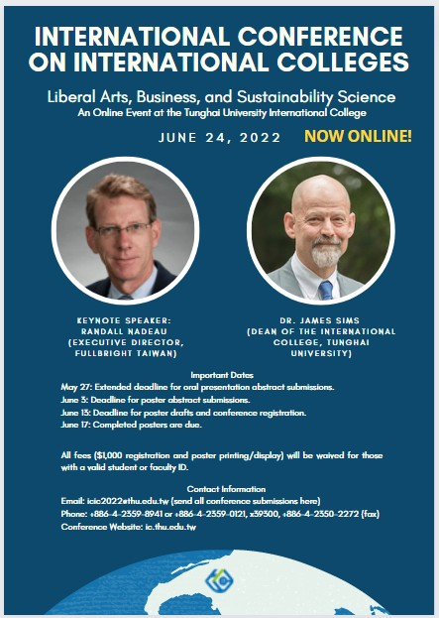

Call for Papers
International Conference on International Colleges:
Liberal Arts, Business and Sustainability Science
June 24, 2022
Online at the Tunghai University International College

In Asia and throughout the world, the emergence of a multicultural and internationally mobile workforce has changed the face of undergraduate education. Universities are witnessing unprecedented demand from students seeking to earn their degrees in a foreign language. Many schools have instituted international colleges that allow students to achieve this goal, while learning side by side with classmates of different nationalities. International colleges are natural distribution hubs for study-abroad programs that enable learners to complete parts of their coursework in other countries. Input from academics, students, and professionals is needed to chart the future of international colleges. The Tunghai University International College cordially invites you to participate its first conference on international colleges.

Conference Themes and Topics for Oral Presentations
There will be three conference themes. Topics will include, but not be limited to, the following:

- Professional Content Courses
International and domestic students enter university with varying levels of subject area content knowledge and language ability, but content courses must serve the needs of all students regretless of their entry levels.
- Catering to classrooms with diverse academic backgrounds and language skills
- Individualized career preparation

- Liberal Arts Education
By studying the humanities, students can develop the ability to think critically, learn from opposing views, and reach a deeper understanding of complex problems. Liberal arts courses can also help students bridge the gap with classmates from other countries.
- The liberal arts curriculum in the context of international colleges
- Student cultural differences
- Communication and language programs

- The Sustainability of International Education
Recently the cross-border movement of students has been hindered by COVID-19 and deteriorating diplomatic relationships. To operate sustainably, international programs must find best practices for minimizing the impact of these and other disruptions.
- The impact of COVID-19
- Online instruction in an international context
- Sustainability in education

In addition to theme-related submissions, we welcome presentations on specific courses (e.g., liberal arts, language, international business, or sustainability) or any other topic relevant to international colleges.

The Student Poster Sessions
The parallel poster sessions will provide an informal setting for students to present and discuss their research and ideas with attendees. Each applicant should work with a faculty member who will act as a sponsor and guide for the poster submission. Submissions should be connected to one of the three poster session categories: Sustainability, Management, and International Education.

Accepted posters will be printed and displayed in one of the three online poster sessions. Participants should be available during this time to interact with attendees through the ICIC2022 online interface. The posters will be evaluated by judges and attendees. At the afternoon closing ceremony, awards will be presented to students with outstanding posters. To encourage participation, ICIC2022 will print all accepted student posters and cover the associated fees.
Oral Presentations Submission Guidelines
- Two documents should be prepared: (a) a file containing the title, an English abstract (under 300 words), and keywords, but no personal identifying information and (b) an oral presenter’s title page.
- Both documents should be sent to icic2022@thu.edu.tw with the subject line “oral presentation.”
- All submissions will undergo double blind peer review by the ICIC 2022 Review Committee.
- Authors will receive the review results by email.
- After acceptance, oral presenters should register and submit a short biography.

Poster Submission Guidelines
- The student and faculty sponsor should submit two documents: (a) the title and an English abstract (under 300 words) with no personal identifying information and (b) a poster presenter’s title page.
- Both documents should be sent to icic2022@thu.edu.tw with the subject line “poster presentation.”
- Applicants and their faculty sponsors will be notified of the review results by email.
- After acceptance, applicants should submit a file containing a draft of the poster.
- The last step is to send the completed poster file.

Keynote Speaker

Dr. Randall Nadeau, Executive Director
Foundation for Scholarly Exchange (Fulbright Taiwan)

Our keynote speaker, Dr. Randall Nadeau, has been Executive Director of the Foundation for Scholarly Exchange, also known as Fulbright Taiwan, since July of 2019. Before his arrival in Taiwan, Dr. Nadeau was Distinguished Professor of Religion at Trinity University, located in San Antonio, Texas (USA). He specializes in Asian religion, history, and culture, and has published several books and articles in his field.

Dr. Nadeau has deep ties to Taiwan and to Tunghai University. He is a one-time Fullbright recipient, and spent the 2014-2015 academic year teaching at the International College.

Online Conference Program (Friday, June 24)
08:30 – 09:00 | Online Orientation: System Navigation and Rules of the Poster Contest Procedures
09:00 – 09:45 | Keynote Speech (Randall Nadeau, Fullbright Taiwan)
09:45 – 10:00 | --- Transition Break ---
10:00 – 11:30 | Session 1A (oral) | Session 1B (oral) | Session 1C (oral)
11:30 – 11:45 | --- Transition Break ---
11:45 – 12:00 | Poster Contest Rules and Procedures
12:00 – 14:00 | Session 2A (Sustainability Posters) | Session 2B (Management Posters) | Session 2C (International Posters)
14:00 – 14:15 | --- Transition Break ---
14:15 – 15:45 | Session 3A (oral) | Session 3B (oral) | Session 3C (oral)
15:45 – 16:00 | --- Transition Break ---
16:00 – 16:45 | Closing Ceremony, Awards and Recognition

Important Dates
May 27: Extended deadline for oral presentation abstract submissions.
June 3: Deadline for poster abstract submissions.
June 13: Deadline for poster drafts and conference registration (all presenters and attendees).
June 17 Completed posters are due.
June 24: ICIC 2022 Conference (held online).

The $1,000 registration fee will be waived for those with a valid student or faculty ID.

Contact Information
Email: icic2022@thu.edu.tw.
Phone: +886-4-2359-8941 or +886-4-2359-0121, x39300
Fax: +886-4-2350-2272
Conference Website: ic.thu.edu.tw (See the “News” section.)

Conference updates will be posted to the conference website. Applicants are advised to check the website on a regular basis.

